Banking Dashboard

Problem Statement –
Develop a basic understanding of risk analytics in banking and financial services and understand how data is used to minimise the risk of losing money while lending to customers.

Data Summary –
Total Clients: 3000
Total Loan: 4.38 bn
Total Deposit: 3.77 bn
Checking Accounts: 963.28 M
Saving Accounts: 698.73 M
Business Lending: 2.6 bn

Solution –
With our dashboards which are created using Power BI latest tools helps the company to make a decision based on the applicant’s profile like if the applicant is likely to repay the loan then approving the loan otherwise not.

About Dataset –
This dataset basically contains information about bank details, various client details which consists of multiple tables which are interlinked with each other through keys like primary key and foreign key. The various tables are Banking Relationship, Client-Banking, Gender, Investment Advisor and Period.

Exploratory Data Analysis using Python –
We began with data preparation and cleaning in Python:
● Data Loading: Imported the dataset using pandas.
● Initial Exploration: Used df.info() to check structure and .describe()for summary statistics.

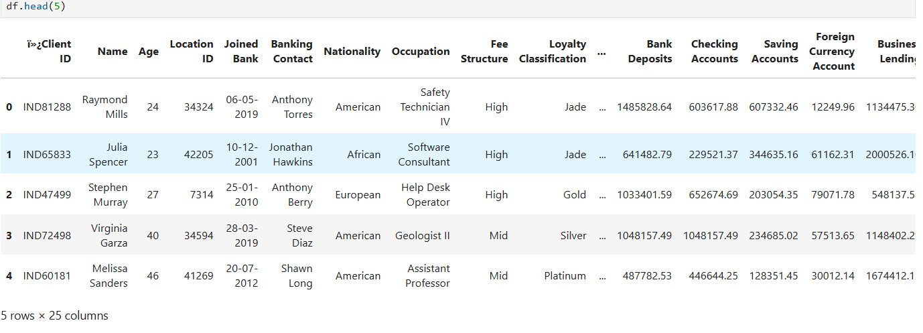

● Finding Correlation Matrix: Used all the Columns and for visualization used heatmap
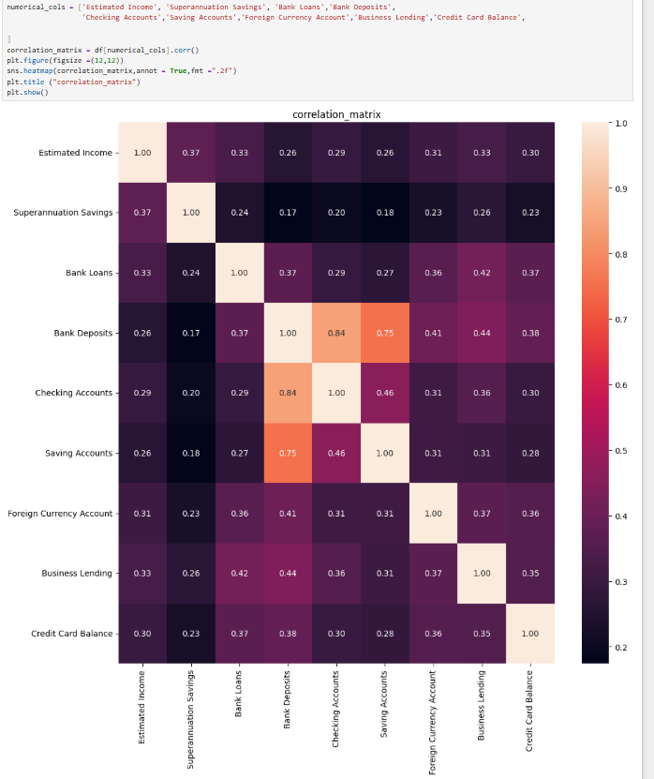

Data Cleaning –
Creating new columns such as Engagement Timeframe, Engagement Days, Income Band and Processing Fees to understand customer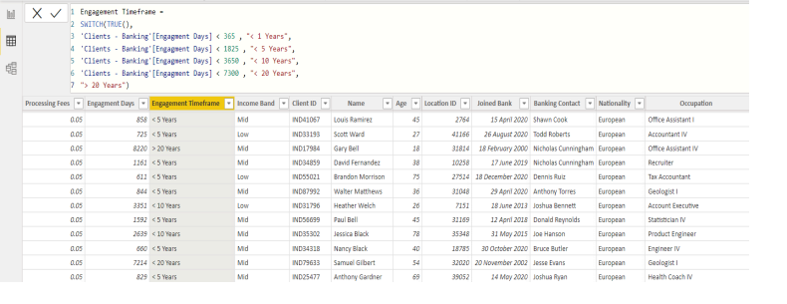
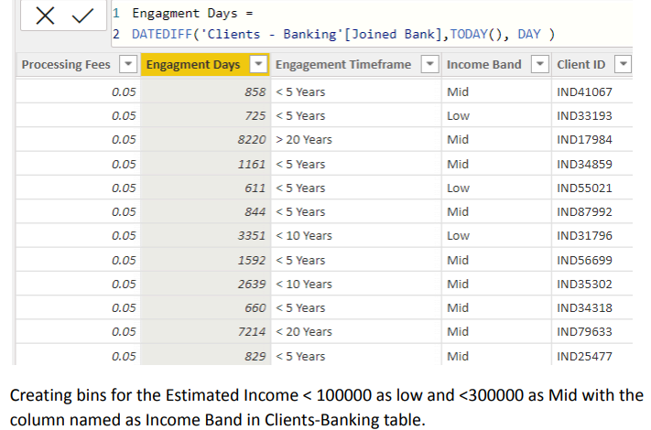
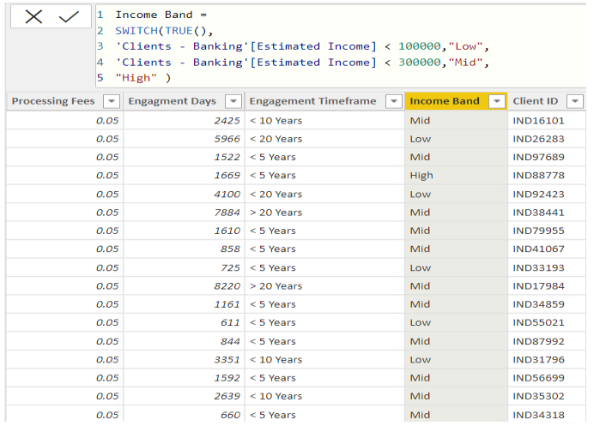

KPIs –
Total Clients, Total Loan, Bank Loan, Business Lending, Total Deposit, Total Fees, Bank Deposit, Checking Accounts, Saving Account, Foreign Currency Account, Engagement Account, Credit Card Balance.

Total Clients:
Total Clients KPI represents total number of clients in banking. Total Clients = DISTINCTCOUNT('Clients - Banking'[Client ID] )


Checking Account Amount:
Checking account amount is nothing but which offers easy access to your money for daily transactional needs. Checking Accounts = SUM('Clients - Banking'[Checking Accounts])

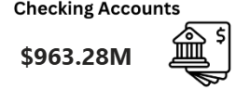

Visualization And Result –

Home
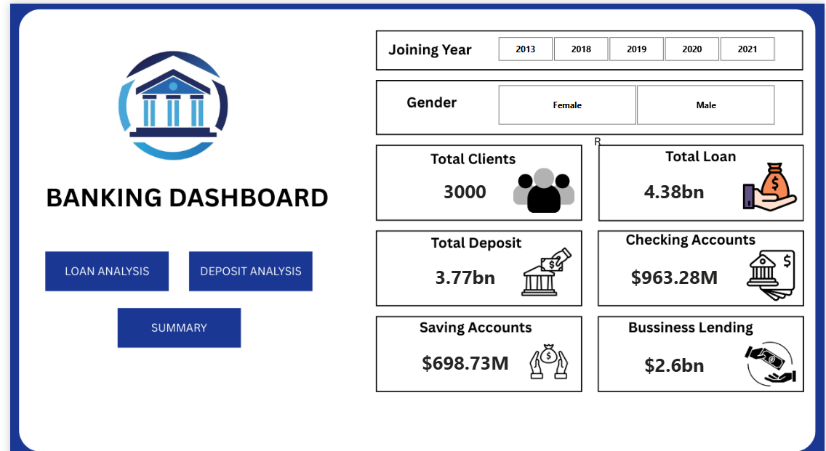

Loan Analysis
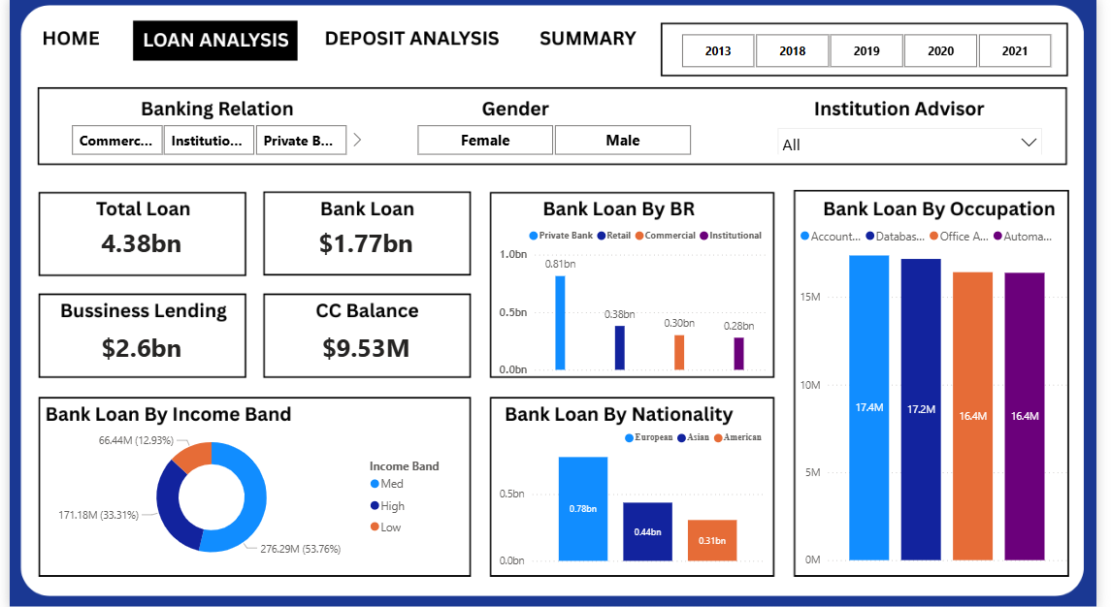

Deposit Analysis
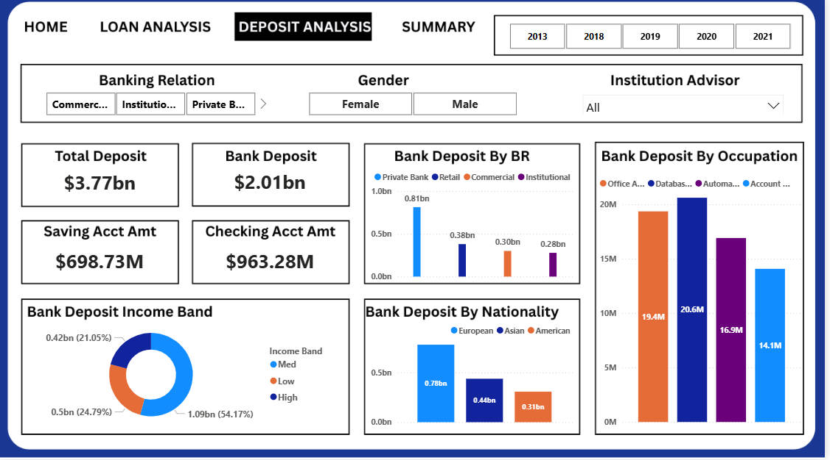

Summary Dashboard
Summary dashboard shows combined KPIs and overall banking insights.

Conclusion –
Power BI dashboards help in decision-making and provide insights into banking KPIs, customer behavior, and financial trends.

